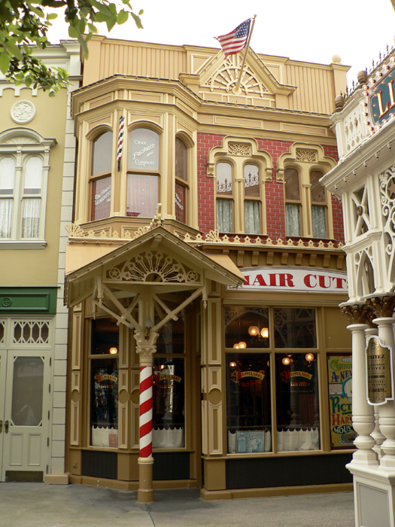

THE BARBERSHOP

One day a man went to have a haircut when the barber decided to take off the man’s head. This would make the barber’s job much easier because the cut the man’s hair whilst his head was still attached would make it difficult for him.

Whilst the customer’s head was having its hair cut the customer had to make do without his head.

As soon as the job was done the man’s head was re- attached to his body. This type of haircut needs removal of the man’s head.